CHM 111.017 Final Sample Exam

Oh man, oh man oh man, not again… Y’all learned chemistry from SI Michael, you can answer any question. Ok I’ll stop. HERE WE GO. The last sample exam, this has the big topic questions from all the different sections that we have done. I am very grateful to have been your SI this semester. It’s been so much fun and I hope y’all keep in touch! Let’s get into it!

1. Mike is looking at different gas companies so that he can cook and not freeze during the winter. He finds that a gas company charges $1.30 for 15.0 ft3 of natural gas.
   1. Convert this rate to dollars per liter of gas.
   2. If it takes 0.304 ft3 of gas to boil a liter of water, starting at room temperature (25oC), how much would it cost to boil a 2.1-L of water?

*1.94* in your textbook

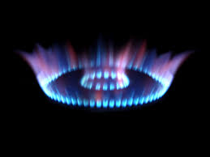

1. Sokka goes to Zuko Ronde talking about some industrial stuff that makes no sense to him whatsoever. However, there is some chemistry involved that he needs help with. It reads: Industrially, hydrogen gas can be prepared by combining propane gas (C3H8) with steam at about 400oC. The products are carbon monoxide and hydrogen gas.
   1. Write a balanced equation for the reaction.
   2. How many kilograms of H2 can be obtained from 2.84 x 103 kg of propane?

*3.139* from book



3) In order to escape the incoming forces from the North, Soren tells Ike that they could create a diversion by burning Magnesium, which emits a humongous amount of blinding light. Soren says that it also releases heat as well. To gain more knowledge for his chemistry book that he’s writing, Soren decides to try his hand at heat transfer with magnesium and water. Soren heats up 2.4 grams of magnesium to 940C and places it in a perfect calorimeter (heat transfer only between these two) with 4.00 grams of water at 20 degrees Celsius. What will be the final temperature?

Note: Specific heat of magnesium: 1.017 (J/g 0C). You should know water.

*Mike original*



4) Luigi is passing someone by Mario Kart and gives’em THE LOOK. Luigi, to add insult to injury, decides to throw a reaction that has taken place in acidic solution at them. Blue shells are overrated. Luigi calculated the following equation to make sure the reaction was balanced before throwing it at them. Complete and balance the following equation in acidic solution.

Zn(s) + NO3- (aq) -> Zn2+ (aq) + NH4+ (aq)

*From Chapter 11 Oxtoby Number 32b*

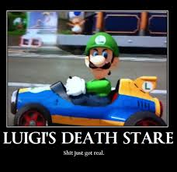

5) Shulk is seeing how the monado sword reacts to light. To do so, he needs to calculate the frequency (Hz) and wavelength (nm) of the emitted photon when an electron drops from n=4 to n=3 level in a hydrogen atom.

*6.31* from your book



PICK ME UP TIME

6) Indicate which of the following sets of quantum numbers in an atom are unacceptable and explain why:

1. (1,1, +0.5, -0.5)
2. (3,0,-1,+0.5)
3. (2, 0, +1, +0.5)
4. (4,3,-2, 0.5)
5. (3,2,+1,1)

7) What is the electron configuration

* + 1. of Chromium?
    2. Sulfur?
    3. Carbon?
  1. What is the shape of
     1. FCl3
     2. NeF5
     3. H2O
  2. Rank the boiling points from lowest to greatest and explain.
     1. H2S, CH3OH, H2O,

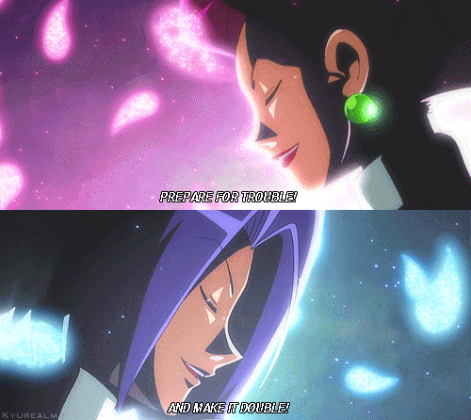

8) Jimmy Neutron is exploring bond enthalpy. For the reaction

C2H6(g) + O2(g) -> CO2(g) + H2O(g)

Predict the enthalpy of reaction from the average bond enthalpies

*8.79* in your book

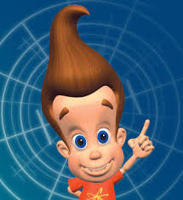

9) Calculate ΔGo for the following reactions at 25oC::

1. 2Mg(s) + O2(g) -> 2MgO(s)
2. 2SO2(g) + O2(g) -> 2SO3(g)
3. 2C2H6(g) + 7O2(g) -> 4CO2(g) + 6H2O(l)

*18.29* in your book. Couldn’t make up a story for this one haha.