

Topics
Section 1.2
Know how to distinguish between Elements, Compounds, and Mixtures (homogeneous and heterogeneous)
Section 1.3
SI Units, Prefixes, Celsius to Kelvin conversion, Density formula
Section 1.4
Physical Property/ Physical Change, Chemical Property/ Chemical Change, Intensive/Extensive properties
Section 1.5
Signficant Figures, Exact Numbers, Accuracy and Percision
Section 1.6
Conversion Factors, Dimentional Analysis
Section 2.1
Law of definite proportions, Law of multiple proportions
Section 2.2
Protons, Neutrons, Electrons

Section 2.3
Mass Number, Atomic Number, Isotopes
Section 2.4
Know groups of Periodic Table
Section 2.5
Be able to calculate avg. atomic mass
Section 2.6
Naming molecular compounds, naming simple acids, recognizing simple alkanes, organic functional groups, emperical and molecular formulas
Section 2.7
Cation and anions, polyatomic ions, naming ionic compounds, naming oxoacids, hydrates
Section 3.1
Calculating molecuar mass
Section 3.2
Calculating % composition

Finding molecular formula from % mass composition

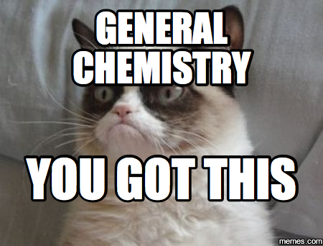

Problems
Section 1.5
1.50 Carry out the following operations as if they were calculations of experimental results, and express each answer in the correct units with the correct number of significant figures
(a) 7.310 km/5.70km
(b) (3.26x10⁻³ mg) - (7.88x10⁻⁵mg)
(c) (4.02x10⁶dm) + (7.74x10⁷dm)
1.52 Three students(A, B, C) are asked to determine the volume of a sample of ethanol. Each student measures the volume three times with a graduated cylinder. The results in milliliters are: A(87.1, 88.2 87.6); B(86.9, 87.1, 87.2); C(87.6, 87.8, 87.9). The true volume is 87.0 mL. Comment on the precision and the accuracy of each students results.

Section 1.6
1.64 Carry out the following conversions: (a) 32.4 yards to centimeters, (b) 3.0x10¹⁰cm/s to ft/s, (c) 1.42 light years to miles (a light year is an astronomical measure of distance—the distance traveled by light year in a year, or 365 days; the speed of light is 3.00x10⁸m/s)
1.66 Aluminum is a lightweight metal (density= 2.70 g/cm³). What is its density in kg/m³?

Section 2.1
2.5, 2.6 in your textbook

Section 2.3
2.20 What is the mass number of an iron atom that has 28 neutrons?
2.26 Determine the mass number of (a) a boron atom with 5 neutrons, (b) a magnesium atom with 14 neutrons, (c) a bromine atom with 46 neutrons, (d) a mercury atom with 116 neutrons

Section 2.6 & 2.7
Name these compounds: Li₂O , SiI4 , CS₂ , NiS , C₂F₂ , HNO_{2,} ICl , MgI₂ , SnI₂ , LiOH, Ca(NO₃)₂ , HClO

Section 3.1
3.4 Calculate the molecular mass (in amu) of each substance (a) C₆H₆O (b)H₂SO₄ (c) C₆H₁₂O₆ (d) BCl₃ (e)N₂O₅
Section 3.2
Calculate percent composition of each element in a, b, and e in the previous problem

A compound containing 5.9265% H and 94.0735% O has a molar mass of 34.01468 g/mol. Determine the empirical and molecular formula for this compound.

What is the empirical formula of a compound that contains 0.783 g of Carbon, 0.196 g of Hydrogen, and 0.521 g of Oxygen?

