CHAPTER 5
5.27 The first step in the inductrial recovery of zinc from the zinc sulfide ore is roasting, that is, the converstion of ZnS to ZnO by heating:
2 ZnS(s) + 3 O₂(g) --> 2 ZnO(s) + 2 SO₂(g) $ΔH= -879 kJ/mol$
Calculate the heat evolved (in kJ) per gram of ZnS roasted. The molar mass of ZnS is 97.48 g.

5.35 A 6.22 kJ piece of copper metal is heated from 20.5°C to 324.3°C. Calculate the amount of heat liberated (in kJ) by the metal. The specific heat of copper is .385 J/g*°C

5.37 A sheet of gold weighing 10.0 g and at a temperature of 18.0°C is placed flat on a sheet of iron weighing 20.0g and at a temperature of 55.6°C. What is the final temperature of the combined metals? Assume that no heat is lost to the surroundings. (Hint: The heat gained by the gold must be equal to the heat lost by the iron). The specific heat of gold is .129 J/g°C and the specific heat of Iron is .444 J/g°C

A 2.50 g sample of zinc is heated, then placed in a calorimeter containing 65.0 g of water. Temperature of water increases from 20.00 ºC to 22.50 ºC. The specific heat of zinc is 0.390 J/gºC. What was the initial temperature of the zinc metal sample? (final temperatures of zinc and water are the same)

From the following enthalpy changes,
4NH3 (g) + 5O2 (g) → 4 NO (g) + 6H2O (l) ∆H° = -1170 kJ
4NH3 (g) + 3O2 (g) → 2N2 (g) + 6H2O (l) ∆H° = -1530kJ
calculate the value of ∆H° for the reaction
N2 (g) + O2 (g) → 2NO (g).

CHAPTER 18
$$ΔH$$ | $ΔS$ | $ΔG$ Prediction

18.29 Calculate the $ΔG$ for the following reaction at 25°C
2 C₆H₆(g) + 7 O₂ (g) --> 4 CO₂ (g) + 6H₂O(l)

The hydrogenation of ethene gas under standard conditions (T = 298.15 K) shows a decrease in disorder (ΔS˚ = -0.1207 kJ/(mol•K)) during an exothermic reaction (ΔH˚ = -136.9 kJ/mol). Predict and then determine whether the reaction is spontaneous or nonspontaneous by calculating ΔG˚.
C₂H₄ (g) + H₂ (g) → C₂H₆ (g)

CHAPTER 6
Energy Levels
N=1 : Lyman Series N=2: Balmer Series N=3: Paschen Series
Aufbau Principle:
Pauli Exclusion Principle:
Hund’s Rule:
What is the energy (in J) of violet light with a frequency of 7.50x10¹⁴ s⁻¹?

6.31 Calcuate the frequency (Hz) and wavelength(nm) of the emitted photon when an electron drops from the n=4 to n=3 level in a hydrogen atom

CHAPTER 7
Zeff:
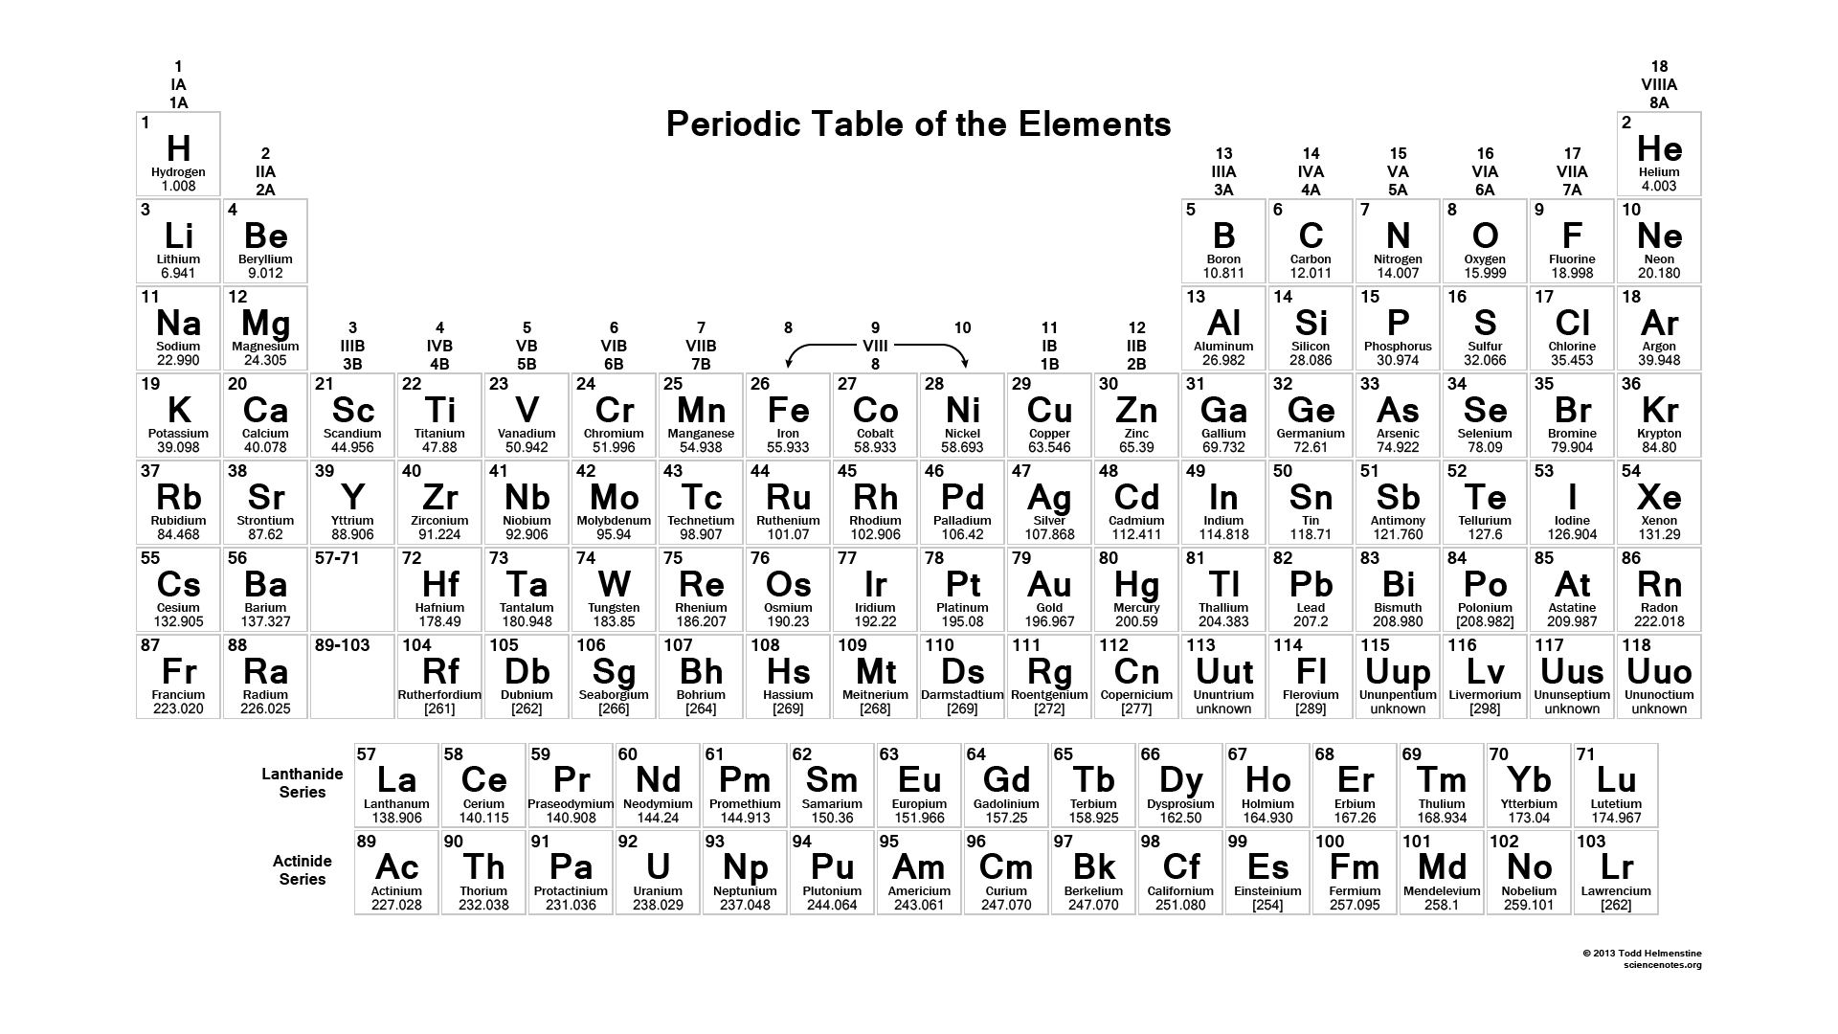
- Atomic radius ____________ as we go down a group
- Atomic radius ____________ as we go left to right across the periodic table
- Ionization energy ____________ as we go down a group
- Ionization energy ____________ as we go left to right across the periodic table
- Electron Affinity ____________ as we go down a group
- Electron Affinity ____________ as we go left to right across the periodic table

Exceptions in filling orbitals:

