Name______________________________
CHM 111 Final Exam Practice
SI Instructor: Daniel Pham

1. Which statement is false? A sigma molecular orbital
(a) may result from overlap of p atomic orbitals perpendicular to the molecular axis (side-on).
(b) may result from overlap of p atomic orbitals along the molecular axis (head-on).
(c) may result from overlap of two s atomic orbitals.
(d) may result from overlap of one s and one p atomic orbitals.
(e) may be either bonding or antibonding.
2. Carbon monoxide has ten bonding electrons and four antibonding electrons. Therefore it has a bond order of
(a) 3
(b) 7
(c) 1
(d) 5/2
(e) 2
3. Draw the molecular orbital diagram for the molecular ion, N2+. The number of electrons in the 2p molecular orbital is:
(a) 0
(b) 1
(c) 2
(d) 3
(e) 4
4.What is the bond order in O2+?
(a) 3.5
(b) 2.0
(c) 1.5
(d) 2.5
(e) 0
5. Draw the molecular orbital diagram for B2. The number of unpaired electrons in the B2 molecule is _____.
(a) zero
(b) 1
(c) 2
(d) 3
(e) 4
6. Which one of the following statements is false?
(a) Valence bond theory and molecular orbital theory can be described as two different views of the same thing.
(b) When one considers the molecular orbitals resulting from the overlap of any two specific atomic orbitals, the bonding orbitals are always lower in energy than the antibonding orbitals.
(c) Molecular orbitals are generally described as being more delocalized than hybridized atomic orbitals.
(d) One of the shortcomings of molecular orbital theory is its inability to account for a triple bond in the nitrogen molecule, N2.
(e) One of the shortcomings of valence bond theory is its inability to account for the paramagnetism of the oxygen molecule, O2.
7. Antibonding molecular orbitals are produced by
(a) constructive interaction of atomic orbitals.
(b) destructive interaction of atomic orbitals.
(c) the overlap of the atomic orbitals of two negative ions
(d) all of these
(e) none of these
8. Which statement regarding stable heteronuclear diatomic molecules is false?
(a) All have bond orders greater than zero.
(b) The antibonding molecular orbitals have more of the character of the more electropositive element than of the more electronegative element.
(c) Their molecular orbital diagrams are more symmetrical than those of homonuclear diatomic molecules.
(d) The bonding molecular orbitals have more of the character of the more electronegative element than of the less electronegative element.
(e) The greater is the difference in energy between two overlapping atomic orbitals, the more polar the resulting bond is, due to electrons occupying the resulting bonding molecular orbital.

- Draw the most plausible Lewis structure for the following, identify the electron domain geometry, molecular geometry, analyze the hybridization of the central atom, and indicate polarity/nonpolarity for the following:
  - XeCl₂

  - IF₄⁻

  - OCN¹⁻

  - COF₂

  - PCl₄F

  - PCl₃

  - CHCl₃

  - CBr₄

  - NO₂⁻

  - NF₃

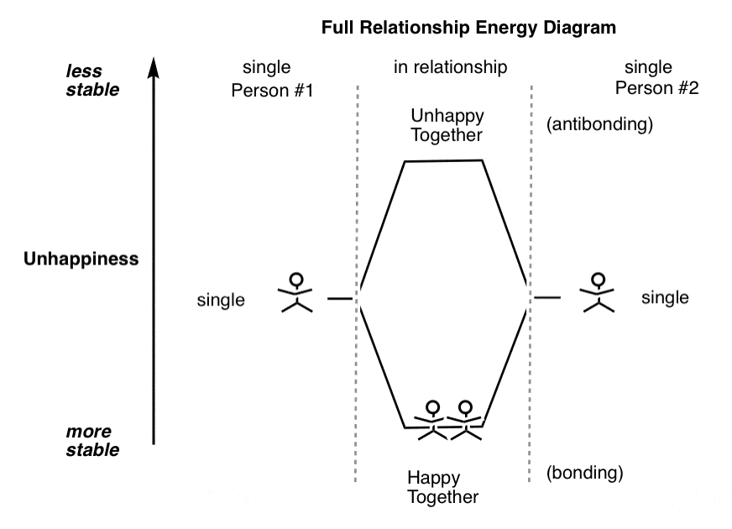

- Give the number of pi bonding electrons and pi antibonding electrons. State bond order.
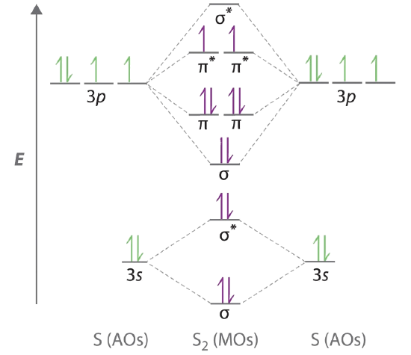

- Fill in the following orbital diagrams and determine Lewis structure and bond order.
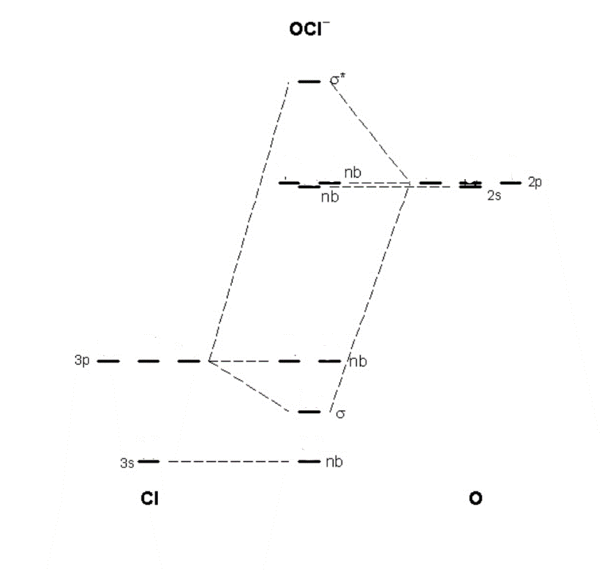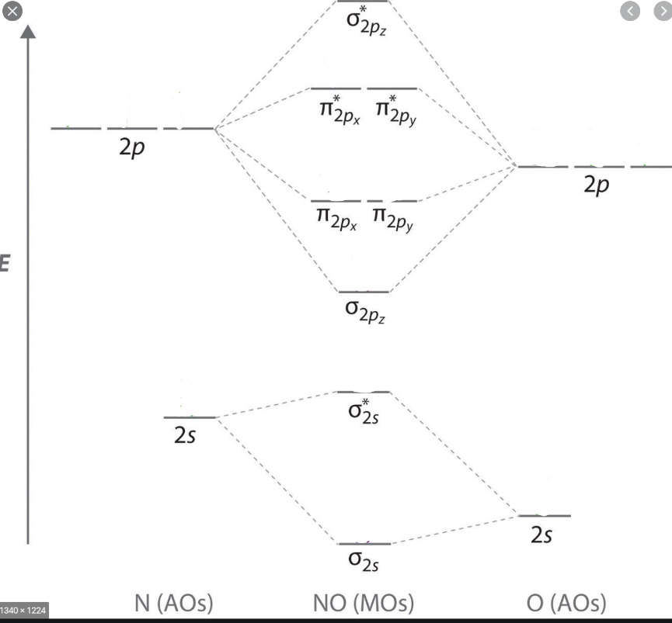

- Calculate the bond dissociation energy for one mole of O−F bonds, given the following data. (Hint: oxygen is the central atom of OF2)

F−F bond dissociation energy = 159 kJ
O=O bond dissociation energy = 498 kJ
F2(g) + 1⁄2O2(g) ---> OF2 (g) ΔH = 28 kJ

