- (a) 2. (a) 3. (b) 4. (d) 5. (c) 6. (d) 7. (b) 8. (c)

9.)
  - Trigonal Bipyramidal, Linear, sp3d, nonpolar
  - Octahedral, Square Planar, sp3d2, Nonpolar
  - Linear, Linear, sp, polar
  - Trigonal Planar, Trigonal Planar, sp2, polar
  - Trigonal Bipyramidal, Trigonal Bipyramidal, sp3d, Polar
  - Tetrahedral, Trigonal Pyramidal, sp3, polar
  - Tetrahedral, Tetrahedral, sp3, Polar
  - Tetrahedral, Tetrahedral, sp3, nonpolar
  - Trigonal Planar, Bent, sp2, polar
  - Tetrahedral, Trigonal Pyramidal, sp3, polar
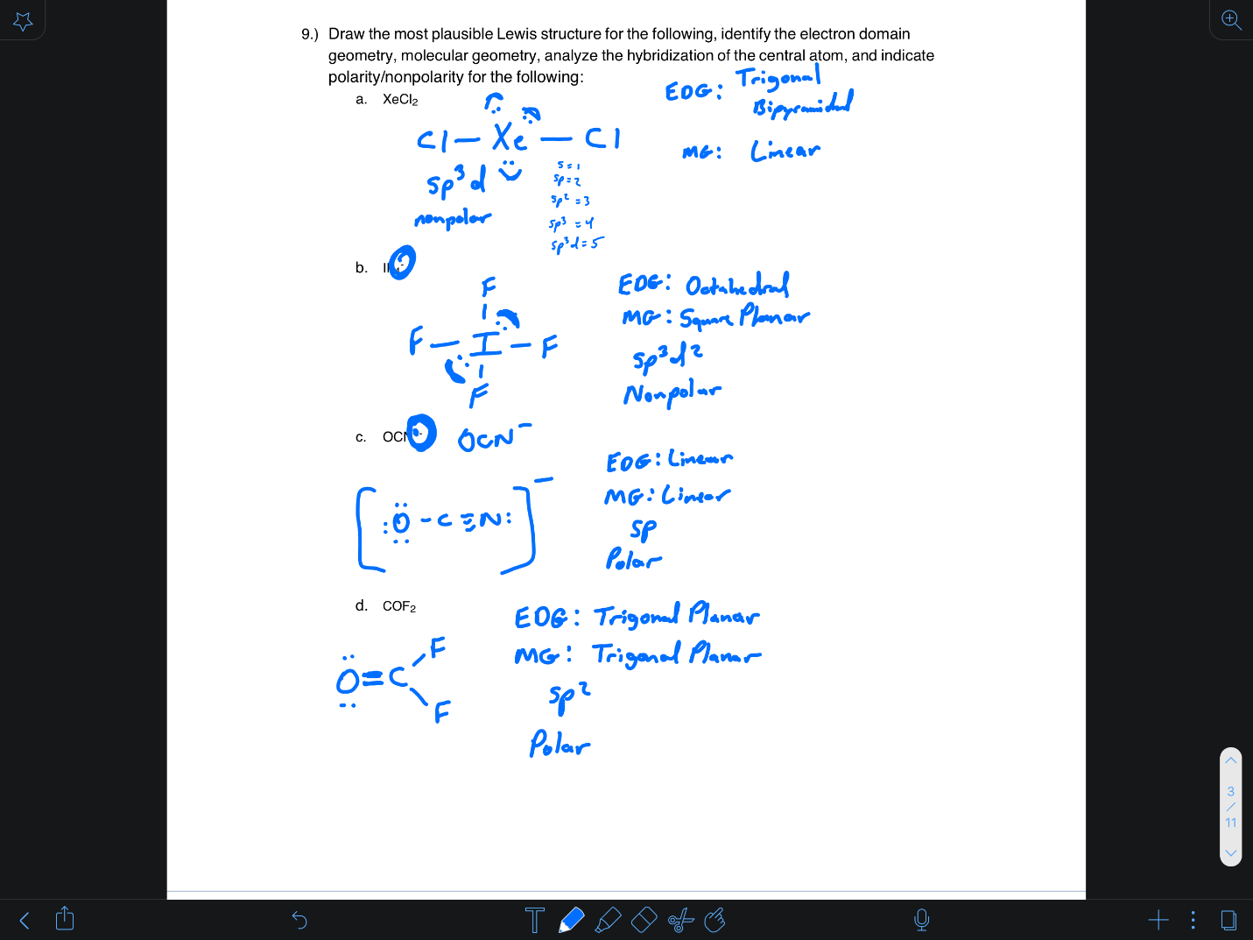
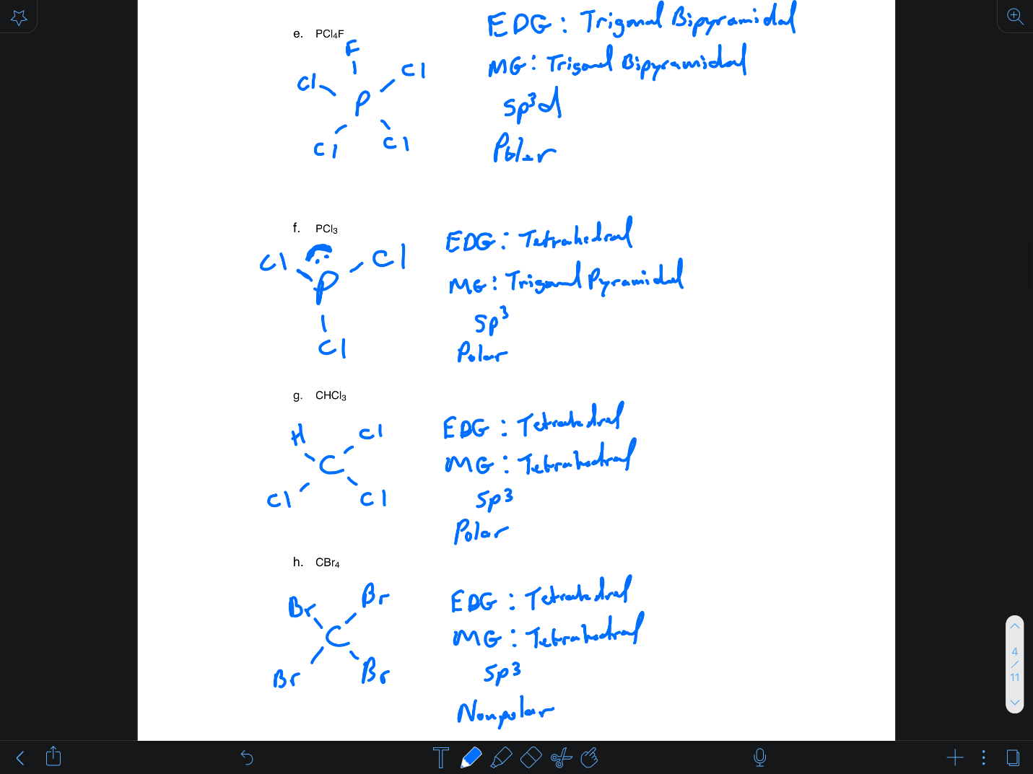
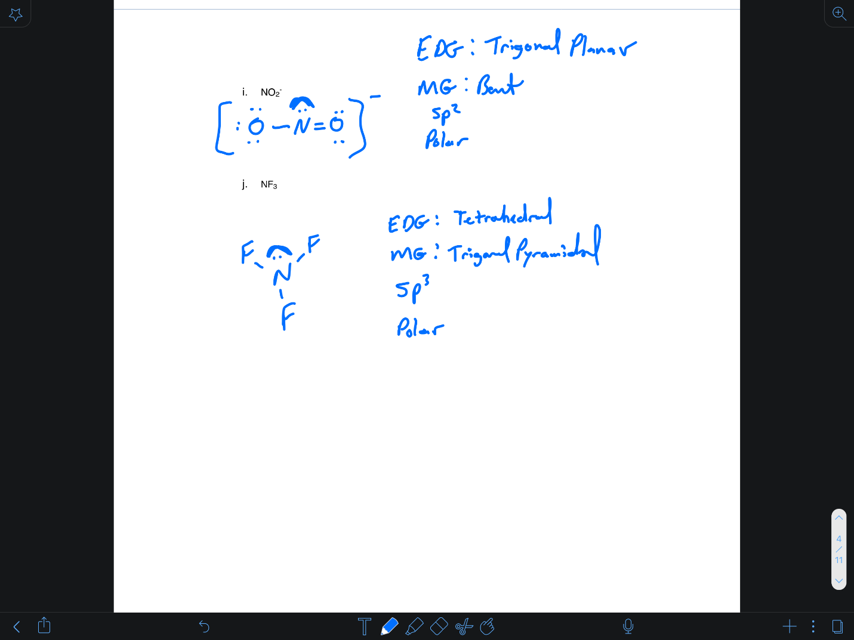

10.) 6 bonding, 2 anti, BO=2
11.) 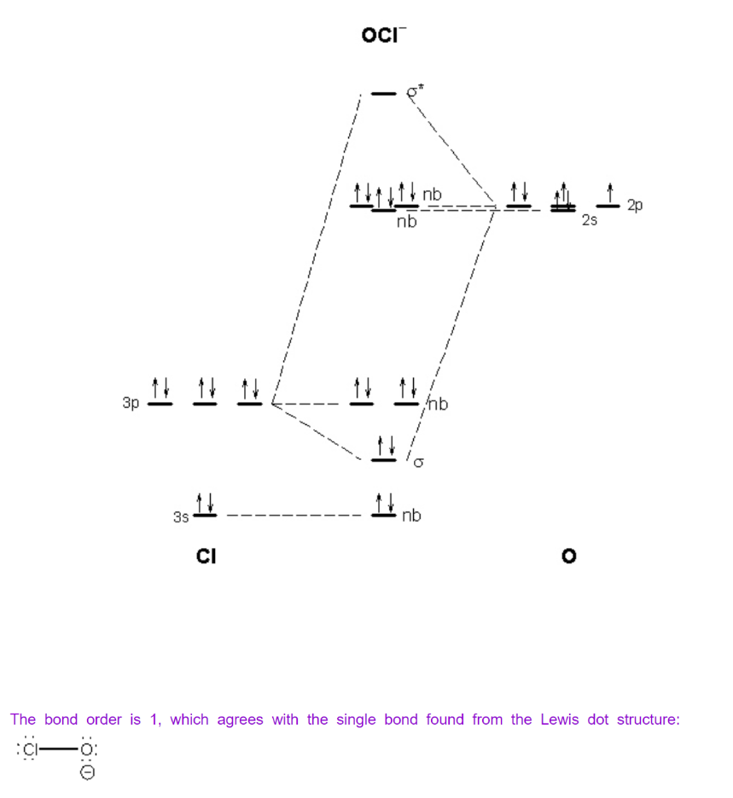
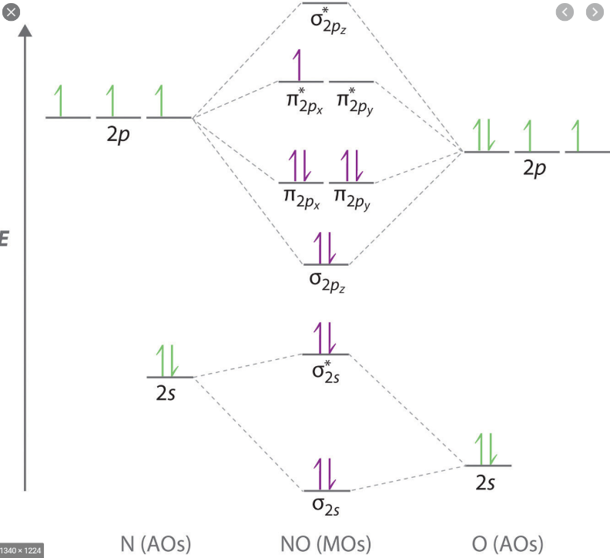
BO= 2.5
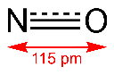
12.) ΔH = Σ E_{reactant bonds broken} − Σ E_{product bonds broken}
reactant bonds broken ---> one F−F; one-half O=O <--- note: ¹⁄₂, not 1
product bonds broken ---> two O−F
28 = [(1) (159) + (¹⁄₂) (498)] − 2x
28 = 408 − 2x
2x = 380
x = 190 kJ

