CHM 112 Practice Problem Set for test 1

1) In one of Professor Layton’s experiments, he’s wondering what to use for an explosion to get into an archaeological site (don’t try exploding things to get into things. That’s not good for the site). He decides on using octane through a combustion reaction. Before going into the site, he tests his calculations and to also try and collect the carbon dioxide to feed to his plants back in town. If his experiment has the octane at a pressure of 7.81 atm, a volume of 3.12 L, and at a temperature of 94ºF, how much carbon dioxide can be collected?

Mike original

2) The Coca-Cola Polar Bear (yes you read that right) is deciding that he should study up on carbonate, the big ingredient in soda. He also knows that soda makes people hyper, so more entropy. Using the data in appendix 2, calculate the standard entropy change and entropy of the surroundings and universe of the following reaction so he can further his studies:
2C₂H₆ (g) + 7O₂(g) -> 4CO₂(g) + 6H₂O(l)
Number 18.14 in your textbook

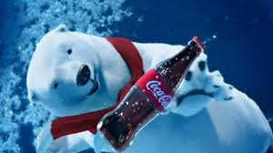

3) Drake decides to go to the chemistry floor on this beautiful day so that the elements won’t get lonely. He decides to also brush up on his chemistry to make a new metaphor in a song. Seeing that 0.37 L of Potassium Permanganate is in a vial at STP, Drake decides to put the calculated Potassium Permanganate in a new solution of 14.37 grams of water. What is the molality?
Mike original


- i. Inigo is attempting to woo Severa by showing off his chemistry knowledge. He decides to name the type of ATTRACTIVE forces that will contribute to the interactions among atoms, molecules, or ions in the following substance. Which ones predominate?
  - KF b. HI c. Rn d. N₂
ii. Firebenders enjoy testing their strength on different boiling points. List the following substances in order of inc normal boiling points and explain reasoning!
  - SO₂ b. He c. HF d. CaF₂ e. Ar
I looked at the periodic table and picked stuff to put lol

- Osmosis Jones is studying osmosis (quite interesting huh) and osmotic pressure. A solution of 6.85 g of a carbohydrate in 100.0 g of water has a density of 1.024 g/mL and an osmotic pressure of 4.61 atm at 20.0ºC. Calculate the molar mass of the carbohydrate.
I forgot which question this is in your book lol
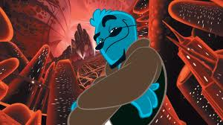
- How many grams of urea [(NH₂)₂CO] must be added to 658 g of water to give a solution with a vapor pressure 2.50 mmHg lower than that of pure water at 30ºC? (The vapor pressure of water at 30ºC is 31.8 mmHg).

From a chemistry edu website

- Professor Birch is wondering what elements are present in the Pokemon world and how they may relate to Castform. It’s been a minute since he’s had chemistry so he brushes up on gas mixing, since maybe the molecules in Castform mix. He starts the following: A 2.5-: flask at 15ºC contains a mixture of N₂, He, and Ne at partial pressures of 0.32 for N₂, 0.15 atm for He, and 0.42 atm for Ne. (A) Calculate the total pressure of the mixture. (B) Calculate the voume in liters at STP occupied by HE and Ne if the N₂ is removed selectively.
Number 10.67 in your book


