Cumulative Final Sample Exam

1. In one of Professor Layton’s experiments, he’s wondering what to use for an explosion to get into an archaeological site (don’t try exploding things to get into things. That’s not good for the site). He decides on using octane through a combustion reaction. Before going into the site, he tests his calculations and to also try and collect the carbon dioxide to feed to his plants back in town. If his experiment has the octane at a pressure of 7.81 atm, a volume of 3.12 L, and at a temperature of 94oF, how much carbon dioxide can be collected?

*Mike original*



1. Bowser has returned from the club and after nearly seizing (shoutout to those who remember this handout lol) he realizes that he could use lasers and the energy from light to try and attack the Mushroom Kingdom. To begin his quest, he first tries to fathom chemistry (he chose physics and biology to study instead. It’s all about that chemistry). So, he looks at the Oxtoby book and decides to answer a question. It reads: Calculate the maximum wavelength of electromagnetic radiation if it is to cause detachment of elcetrons from the surface of metallic tungsten, which has a work function of 7.29 x 10-19 J. If the maximum speed of the emitted photoelectrons is to be 2.00 x 106 m/s, what should the wavelength of the radiation be?

*From Chapter 4 Number 28*



1. In order to escape the incoming forces from the North, Soren tells Ike that they could create a diversion by burning Magnesium, which emits a humongous amount of blinding light. Soren says that it also releases heat as well. To gain more knowledge for his chemistry book that he’s writing, Soren decides to try his hand at heat transfer with magnesium and water. Soren heats up 2.4 grams of magnesium to 940C and places it in a perfect calorimeter (heat transfer only between these two) with 4.00 grams of water at 20 degrees Celsius. What will be the final temperature?

Note: Specific heat of magnesium: 1.017 (J/g 0C). You should know water.

*Mike original*



1. 200.0 g of Benzene and 115.0 g of Toluene are mixed at 400C. At 400C, the vapor pressure of pure benzene is 187.5 mmHg and that of Toluene is 59.2 mmHg. What is the vapor pressure over the mixture?

*From the notes*

*No story for this one. If you know how to do this one, then one particular SI session is story enough.*



1. Pick me up time! Time to review some things that I feel can be quickly done and reviewed:
   1. What is the diatomic molecular orbital model for oxygen? Show the distribution of electrons. Is it paramagnetic?
   2. What is the electron configuration
      1. of Chromium?
      2. Sulfur?
      3. Carbon?
   3. What is the shape of
      1. FCl3
      2. NeF5
      3. H2O
   4. Rank the boiling points from lowest to greatest and explain.
      1. H2S, CH3OH, H2O,

*From all over the place*

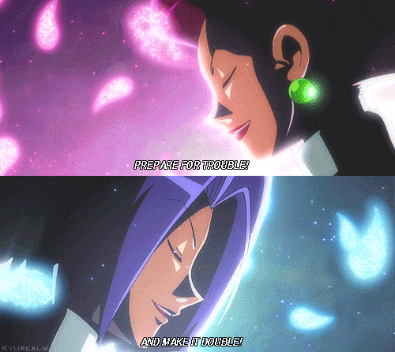

1. Luigi is passing someone by Mario Kart and gives’em THE LOOK. Luigi, to add insult to injury, decides to throw a reaction that has taken place in acidic solution at them. Blue shells are overrated. Luigi calculated the following equation to make sure the reaction was balanced before throwing it at them. Complete and balance the following equation in acidic solution.

Zn(s) + NO3- (aq) -> Zn2+ (aq) + NH4+ (aq)

*From Chapter 11 Number 32b*



1. The molar enthalpy of fusion of solid ammonia is 5.65 kJ/mol, and the molar entropy of fusion is 28.9 J/K x mol.
   1. Calculate the Gibbs free energy change for the melting of 1.00 mol ammonia at 170 K.
   2. Calculate the Gibbs free energy change for the conversion of 3.60 mol solid ammonia to liquid ammonia at 170 K.
   3. Will ammonia melt spontaneously at 170 K?
   4. At what temperature are solid and liquid ammonia in equilibrium of 1 atm?

*Chapter 13 Number 29. Couldn’t think of a story for this one haha*

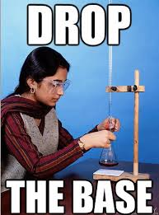

1. Red and his team left to search for enlightenment and to continue improving their knowledge. They stumble across a body of water where he sees Suicune, purifying the water and making it clean for Pokemon to inhabit. Inspired by this, Red realizes that he can create a solution, a buffer solution, which can prevent changes in pH. He decides to make a buffer solution with carbonic acid (H2CO3). Ka for carbonic acid is 4.3 x 10-7.
   1. What is the concentration for a solution made of 65.2 grams of Carbonic Acid in water?
   2. Red decides to take it a step further to test if he has the concept down. For a new reaction, the carbonic acid is then mixed with 25 mL of NaOH first and then put in water. What is the pH then?
      1. What if 10 mL of HCl is then added to the above solution after finding the new concentrations for part b?

*Mike original (I think this works haha)*

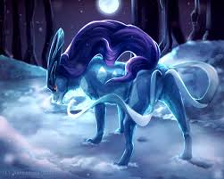

1. A Ni l Ni2+ ll Ag+ l Ag galvanic cell is constructed in which the standard cell potential is 1.03 V. To see if this could create a spontaneous reaction and aid in preserving energy, Kaiba decides to investigate so that he could get more money and build a new Blue-Eyes themed dueling arena. To do so, he has to calculate the free energy change at 250C when 1.00 g of silver plates out, if all concentrations remain at their standard value of 1 M throughout the process. What is the maximum electrical work done by the cell on its surroundings during this experiment?

*Chapter 17 Number 11.*



1. What is the half-life of a one reactant reaction with a k of 0.0462 (what are the units?)

*Mike original*

If you did number 10 correctly, then you get an answer of 15. I made it equal 15, because that’s how many weeks I have been your SI. I just want to say that I have enjoyed being your SI. This was my first semester being one and you all (there would be no SI without you all) really made it special and memorable. Whether you came once or were a regular, you made each session funny, informative, and most of all, fun. There is no fun without fundamentals and you guys had it all. You guys put up with the times that I was a little confused (cough the quantum section), but you were patient with me and we got through it. You also put up with my short rants (I promise Dr. Pounds, they were short haha) when I was stressed with biochemistry and physics before we began some sessions. I would be having a bad day some days, but y’all’s smiles, jokes and the occasional snapchat foolery (you know who you are who did that) made me positive. I got to know some of you, and I am really glad that I did. I am honored to be your friend and that you allowed me to help and hopefully make a difference in your chemistry endeavors. This goes for all of you, I will still be around next semester (this is not good-bye) and I hope that we can still talk, whether it be at the café or just saying hi around campus or even hanging out. I’m not gonna lie, I really will miss seeing you all almost every single day, it was never a boring class period without you all (and your teaching Dr. Pounds!). So, good luck on your finals everyone, and if you need something or want to chat, holla at ya boy!

Remember, you can’t find success without a little struggle!

~Michael Kshatri 