Determination of Heat Capacity at Constant Volume of Carbon Dioxide Using an Oscilloscope
Holly S. Burrell*, Kimberly S. Lammers, Shanna M. Smith, Andrew Pounds, Ph.D.
Department of Chemistry, Mercer University, Macon, GA 31207; *Holly.burrell@live.mercer.edu
Carbon dioxide; Heat capacity; Oscilloscope; Frequency generator; Nitrogen; Velocity of sound

EXPERIMENTAL The heat capacity of carbon dioxide can be calculated by finding the speed of sound in carbon dioxide. This was done using a PVC pipe that was 93 cm long. To calculate the sped of sound in carbon dioxide, an experiment with a known speed of sound was done first. The speed of sound in air (at 40% humidity) and nitrogen are literature values easily looked up and are used as calibrating gases. The speed of sound in air is 343.814 m/s and the velocity of sound in nitrogen is 334 m/s [1]. Using an oscilloscope, the frequency was measured as the frequency generator generated frequencies that traveled through the pipe to the microphone. The in-phase and out-of-phase readings and their frequencies were then recorded. One is able to derive an equation from
$$u^{2}=γ\frac{\text{RT}}{M}=\frac{(C_{p}{\text{/C}}_{v})\text{RT}}{M}$$ | (1)
to obtain an overall equation for C_{v} where u is the speed of sound and M is the molecular mass. Using C_{p}=C_{v}+R and by transferring all C_{v} terms on one side of the equation, one finds the equation to be
$$C_{v}u^{2}−\frac{C_{v}\text{RT}}{M}=\frac{R^{2}T}{M}$$ | (2)
In isolating C_{v} and using the equation u_{CO2}=(u_{N2}/m_{N2})(m_{CO2}), the final equation for C_{v} is found to be
$$C_{v}=\frac{\frac{R^{2}T}{M}}{(\frac{u_{N2}m_{\text{CO}2}}{m_{N2}})^{2}−\frac{\text{RT}}{M}}$$ | (3)
where m is slope (the only measured values) and u is the velocity of sound. It should be noted that the slope and speed of sound for nitrogen was used in the equation because the pure nitrogen entering the pipe was dry, as opposed to the air that was at 40% humidity. The slopes can be observed in Table 1.

Table 1.
 | Slope | Average Slope and Error | Temp. (K)
Air-Trial 1 | 295.96±31.52 | 296.10±32.43 | 295.05
Trial 2 | 296.32±33.26 | 296.10±32.43 | 295.30
Trial 3 | 296.01±32.52 | 296.10±32.43 | 295.45
N₂-Trial 1 | 303.18±32.57 | 303.02±32.70 | 295.9
Trial 2 | 303.09±32.81 | 303.02±32.70 | 295.85
Trial 3 | 302.80±32.72 | 303.02±32.70 | 295.80
CO₂-Trial 1 | 230.69±16.30 | 235.59±20.62 | 296
Trial 2 | 235.92±28.59 | 235.59±20.62 | 296
Trial 3 | 231.16±16.98 | 235.59±20.62 | 296.05
CO₂ (low temp)-Trial 1 | 212.41±25.32 | 213.12±25.21 | 253.65
Trial 2 | 214.21±24.44 | 213.12±25.21 | 253.75
Trial 3 | 212.75±25.87 | 213.12±25.21 | 253.8
Using this equation, one obtains the experimental heat capacity for carbon dioxide at 297 K and 253.73 K to be 41.1897 and 54.9699 J/mol-K, respectively. The standard error in these values can be calculated using
$$\text{error}=\text{temp}\text{.}\text{} \text{error}+13\sqrt{\sum_{i=1}^{3}{({\text{error}}_{i})}}(N_{2} {\text{slope}}_{i})^{2}+13\sqrt{\sum_{i=1}^{3}{({\text{error}}_{i})}}({\text{CO}}_{2} {\text{slope}}_{i})^{2}$$ | (4)
The error for temperature is ±1%, so the error for the room temperature readings is ±0.24. For the dry ice readings, the error is ±0.1927 The error for slope is calculated using Monte Carlo regressions [2]. Therefore, the total error of heat capacity at room temperature is ±1612.236. The total error of the heat capacity at the temperature of the dry ice is ±1618.4009. Sample graphs of trials for each experiment are shown in Figures 1-4.
Figure 1.
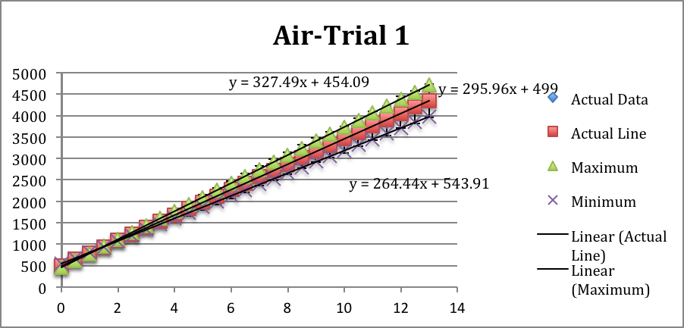
Figure 2.
$$C_{v}=52\text{R+R}\sum_{i=1}^{4}{({\text{hcv}}_{i}\text{/kT})^{2}e^{{\text{hcv}}_{i}\text{/KT}}(e^{{\text{hcv}}_{i}\text{/kT}}\text{-1})^{2}}$$ | (5)
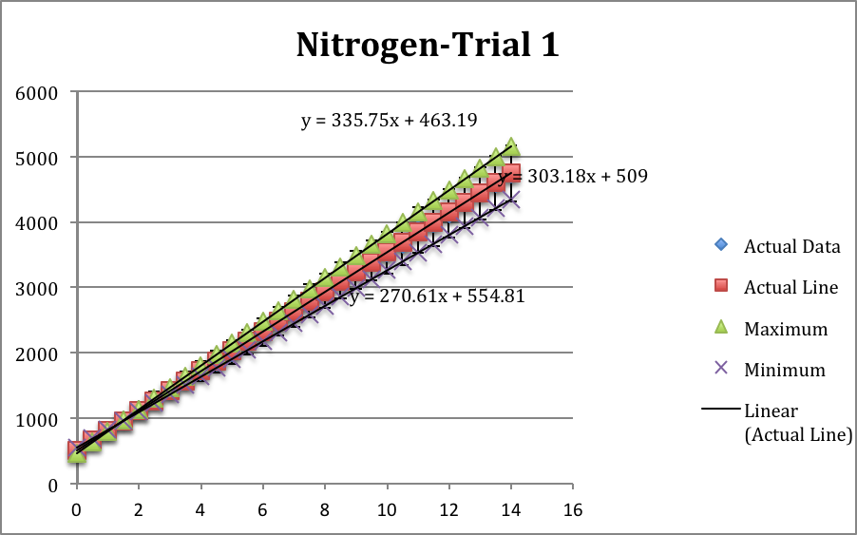

Figure 3.
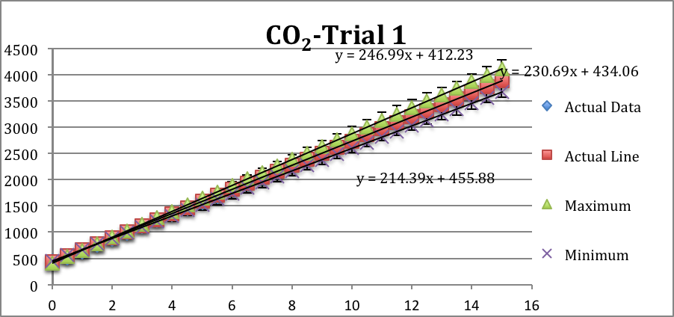
Figure 4.
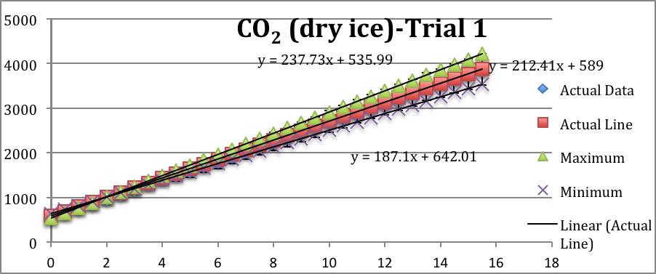
To determine the theoretical values of heat capacity at constant volume, a summation equation was used:
The four fundamental vibrational frequencies used were 1340, 2349, 667, and 667 cm⁻¹ [1]. When plugged into the above equation, the vibrational contribution to the heat capacity for carbon dioxide at room temperature (297 K) was 8.00196 J/mol-K. At 253.73 K, the contribution was 5.93514 J/mol-K. This puts the heat capacity at constant volume to be 28.78696 and 26.72014 J/mol-K, respectively. These values allow for comparison with the experimentally calculated values.
The error is relatively large and leaves much room for variation in the experimental values of heat capacity. It is, in fact, much larger than the actual heat capacity values. This leaves one to wonder why the error is so incredibly high. The error should not exceed the actual values. However, this does ensure that the theoretical values of heat capacity fall within the error bars.
REFERENCES
[1] CRC Handbook of Chemistry and Physics, 70th ed.; Boca Raton, FL, 1990.
[2] Pounds, A.J. Mercer University, Macon, GA. Personal Communication, 2011.
[3] Silbey, Robert J.; Aberty, Robert A.; Bawendi, Moungi, G. Rotational and Vibrational Spectroscopy. In Physical Chemistry, 4th ed.; Brennan, Deborah, McFadden, Patricia, Batey, Martin, Eds.; Wiley: Hoboken, 2005; 487.

